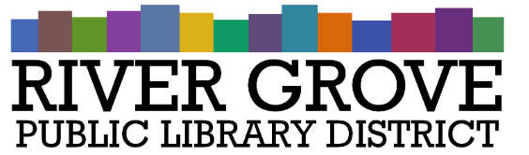
River Grove Public Library District
8301 Grand Ave
River Grove, IL 60171
708.453.4484

Board Meeting Agenda
Date: 9/9/2026
Time: 6:00pm
Place: Library – Conference Room

- CALL TO ORDER

- GUESTS
- APPROVAL OF MINUTES
a. Regular Meeting 8/12/2026

- CORRESPONDENCE

- TREASURER’S REPORT

- BILLS FOR APPROVAL

- PRESIDENT’S REPORT

- DIRECTOR’S REPORT

- COMMITTEE REPORTS
- OLD BUSINESS

- NEW BUSINESS
a. ACTION: Approval of Budget and Appropriations Ordinance for FY 26-27
b. ACTION: Patron Code of Conduct Policy
c. ACTION: Video Surveillance Policy
d. ACTION: Public Bulletin Board Policy
e. ACTION: Landscaping Quote from Green Scapers
f. DISCUSSION: Automatic Door Opener Install

- PUBLIC COMMENTS

- EXECUTIVE SESSION

- ADJOURNMENT

