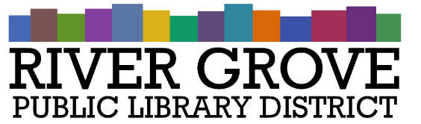
River Grove Public Library District
8301 Grand Ave
River Grove, IL 60171
708.453.4484

Board Meeting Agenda
Date: 8/12/2026
Time: 6:00pm
Place: Library – Meeting Room

- CALL TO ORDER

- GUESTS

- APPROVAL OF MINUTES
a. Approval of regular meeting minutes 7/8/2026

- CORRESPONDENCE

- TREASURER’S REPORT

- BILLS FOR APPROVAL
a. Pay App 12 for Structures Construction

- PRESIDENT’S REPORT

- DIRECTOR’S REPORT

- COMMITTEE REPORTS
- BUILDING AND GROUNDS

- OLD BUSINESS

- NEW BUSINESS
a. Discussion: River Grove Public Library District strategic plan
b. ACTION: Cancel NIR Roof Care plan
c. ACTION: Quote for additional shelving
d. ACTION: SenSource people counter quote

- PUBLIC COMMENTS

- EXECUTIVE SESSION

- ADJOURNMENT

