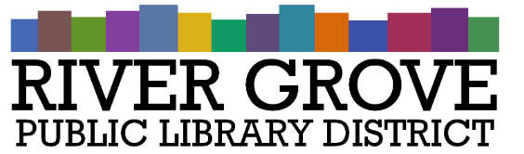
River Grove Public Library District
8638 W Grand Ave
River Grove, IL 60171
708.453.4484

Board Meeting Agenda
Date: 8/9/2023
Time: 6:30pm
Place: Library – Youth Room

- CALL TO ORDER

- GUESTS

- APPROVAL OF MINUTES
  - Regular Meeting Minutes – July 12th, 2023

- CORRESPONDENCE

- TREASURER’S REPORT
  - Approval of July 2023 Treasurer’s Report (ACTION ITEM)

- BILLS FOR APPROVAL
  - Approval of Bills presented in August 2023 (ACTION ITEM)

- PRESIDENT’S REPORT

- DIRECTOR’S REPORT
  - State of the library
  - Library statistics

- COMMITTEE REPORTS

- BUILDINGS AND GROUNDS

- OLD BUSINESS
- NEW BUSINESS
  - Adopt Tentative Budget & Appropriations Ordinance – to be placed on file for 30 days (ACTION)
  - Notice of Budget & Appropriations Hearing (ACTION)
  - Review of Closed Session Minutes (ACTION)
  - Accounting Quotes (ACTION)
  - IPLAR 2022-2023 (ACTION)
  - New Library Building Renovation - Discussion

- PUBLIC COMMENTS

- EXECUTIVE SESSION
- ADJOURNMENT

