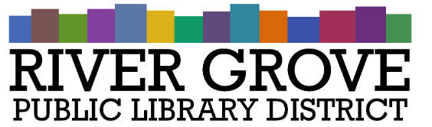
River Grove Public Library District
8638 W Grand Ave
River Grove, IL 60171
708.453.4484

Board Meeting Agenda
Date: 3/11/2026
Time: 6:00pm
Place: Library – Youth Room

- CALL TO ORDER

- GUESTS

- APPROVAL OF MINUTES
a. Approval of regular meeting minutes 2/11/2026

- CORRESPONDENCE

- TREASURER’S REPORT

- BILLS FOR APPROVAL
a. Pay App 7 for Structures Construction

- PRESIDENT’S REPORT

- DIRECTOR’S REPORT

- COMMITTEE REPORTS
- BUILDING AND GROUNDS

- OLD BUSINESS

- NEW BUSINESS
a. DISCUSSION: Construction Timeline Update
b. DISCUSSION: Financial Planning for FY 26-27 and beyond

- PUBLIC COMMENTS

- EXECUTIVE SESSION

- ADJOURNMENT

