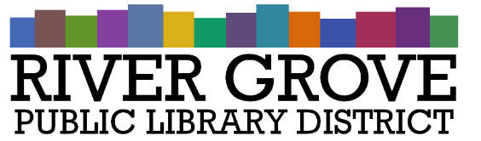
River Grove Public Library District
8638 W Grand Ave
River Grove, IL 60171
708.453.4484

Special Meeting Agenda
Building Committee
Date: 4/22/2024
Time: 4:00pm
Place: Library

- CALL TO ORDER
- ROLL CALL
  - Guests: Design Architect and Engineering Group (DAE)
- PUBLIC COMMENTS
- NEW BUSINESS
a. Building Project Discussion and Update With DAE
- ADJOURNMENT

