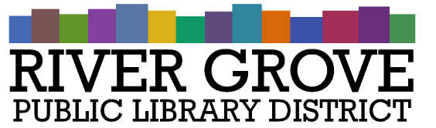
River Grove Public Library District
8638 W Grand Ave
River Grove, IL 60171
708.453.4484

Board Meeting Agenda
Date: 9/10/2025
Time: 6:00pm
Place: Library – Youth Room

- CALL TO ORDER

- GUESTS

- APPROVAL OF MINUTES
a. Regular Meeting 8/13/2025

- CORRESPONDENCE

- TREASURER’S REPORT

- BILLS FOR APPROVAL

- PRESIDENT’S REPORT

- DIRECTOR’S REPORT

- COMMITTEE REPORTS
- OLD BUSINESS

- NEW BUSINESS
a. ACTION: Approval of outstanding change orders for 8301 W Grand project
b. ACTION: Approval of Pay App #1 to Structures Construction for 8301 W Grand project
c. DISCUSSION and ACTION: Building and Maintenance Levy Ordinance
d. ACTION: Purchase of hour block from OSG
e. ACTION Signage quotes from All American Sign and Integrity Sign

- PUBLIC COMMENTS

- EXECUTIVE SESSION

- ADJOURNMENT

