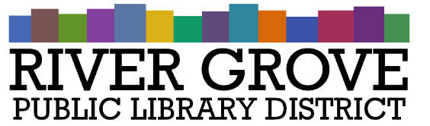
River Grove Public Library District
8638 W Grand Ave
River Grove, IL 60171
708.453.4484

Board Meeting Agenda
Date: 10/8/2025
Time: 6:00pm
Place: Library – Youth Room

- CALL TO ORDER

- GUESTS

- APPROVAL OF MINUTES
a. Regular Meeting 9/10/2025

- CORRESPONDENCE

- TREASURER’S REPORT

- BILLS FOR APPROVAL

- PRESIDENT’S REPORT

- DIRECTOR’S REPORT

- COMMITTEE REPORTS
- OLD BUSINESS

- NEW BUSINESS
a. ACTION: Approval of Levy Ordinance for FY 25-26
b. ACTION: Approval of Pay App #2 to Structures Construction for 8301 W Grand project
c. ACTION: Furniture Quote from Media Technologies
e. ACTION Signage quotes from All American Sign, Integrity Sign, and Paldo Sign Company

- PUBLIC COMMENTS

- EXECUTIVE SESSION

- ADJOURNMENT

