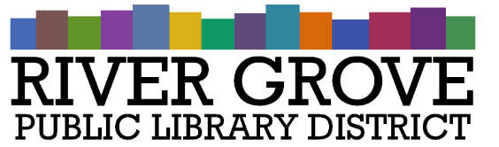
River Grove Public Library District
8301 Grand Ave
River Grove, IL 60171
708.453.4484

Budget and Ordinance Hearing Agenda
Date: 9/9/2026
Time: 5:30pm
Place: Library – Conference Room

- CALL TO ORDER

- PUBLIC COMMENTS

- ADJOURNMENT

