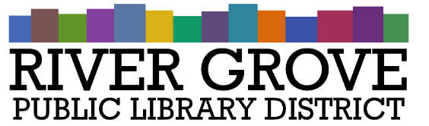
River Grove Public Library District
8638 W Grand Ave
River Grove, IL 60171
708.453.4484

SPECIAL MEETING AGENDA

Monday, November 27th, 2023
6:30 PM
I. CALL TO ORDER
II. BUSINESS
a. Building Project Considerations Presentation
b. Board Discussion – Building Project Options
c. POSSIBLE ACTION:
I. Engberg Anderson 8301 W. Grand Phase 1 Reroof Proposal
ii. Engberg Anderson 8638 W. Grand Conceptual Work Proposal
iii. Owners’ Representative Proposals
IV. PUBLIC COMMENTS
V. ADJOURNMENT

