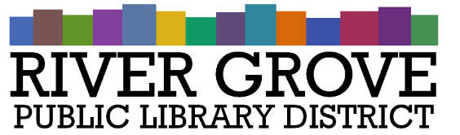
River Grove Public Library District
8638 W Grand Ave
River Grove, IL 60171
708.453.4484

Board Meeting Agenda
Date: 12/10/2025
Time: 6:00pm
Place: Library – Youth Room

- CALL TO ORDER

- GUESTS

- APPROVAL OF MINUTES
a. Approval of regular meeting minutes 11/12/2025

- CORRESPONDENCE

- TREASURER’S REPORT
a. FY25 Treasurer’s Report

- BILLS FOR APPROVAL

- PRESIDENT’S REPORT

- DIRECTOR’S REPORT

- COMMITTEE REPORTS
- BUILDING AND GROUNDS

- OLD BUSINESS
a. ACTION: Select and approve signage quote for 8301 W Grand

- NEW BUSINESS
a. ACTION: Approve Pay App 4 for Structures Construction
b. ACTION: Approve board meeting dates for 2026
c. ACTION: Approve library closures for 2026

- PUBLIC COMMENTS

- EXECUTIVE SESSION

- ADJOURNMENT

