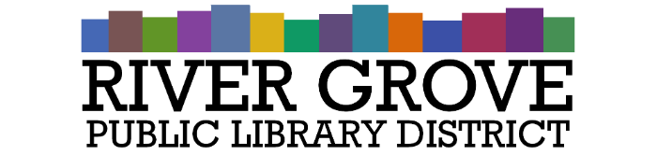**River Grove Public Library District**

8638 W Grand Ave

River Grove, IL 60171

708.453.4484

**Special Board Meeting Agenda**

**Date: 5/21/2025**

**Time: 6:00pm**

**Place: Library – Youth Room**

1. **CALL TO ORDER**
2. **GUESTS**

a. Gabe Alvarez, CCS

1. **OLD BUSINESS**a. ACTION: Builder’s Risk Policy
2. **NEW BUSINESS**

a. ACTION: Review and approval of Structures Construction bid to renovate property at 8301 Grand Avenue

1. **PUBLIC COMMENTS**
2. **EXECUTIVE SESSION**
3. **ADJOURNMENT**