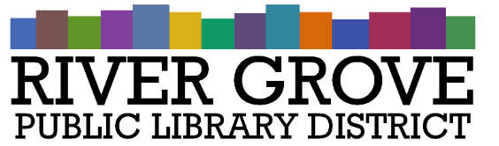
River Grove Public Library District
8638 W Grand Ave
River Grove, IL 60171
708.453.4484

Board Meeting Agenda

Truth in Taxation Hearing
Date: 11/8/2023
Time: 6:00 pm
Place: Library – Youth Room

- CALL TO ORDER
- PUBLIC COMMENTS
- ADJOURNMENT

Regular Meeting

Date: 11/8/2023
Time: 6:30pm
Place: Library – Youth Room

- CALL TO ORDER

- GUESTS
- APPROVAL OF MINUTES
  - Regular Meeting Minutes – 10/11/2023
  - Special Meeting Minutes – 9/27/2023

- CORRESPONDENCE
  - Notice of Inactivity – Byline Bank

- TREASURER’S REPORT
  - Approval of October 2023 Treasurer’s Report (ACTION ITEM)

- BILLS FOR APPROVAL
  - Approval of Bills presented in November 2023 (ACTION ITEM)

- PRESIDENT’S REPORT

- DIRECTOR’S REPORT

- COMMITTEE REPORTS

- BUILDINGS AND GROUNDS

- OLD BUSINESS
  - Programming Policy – Second Reading (ACTION)
- NEW BUSINESS
  - Adopt Tax Levy Ordinance 2023-2024 (ACTION)
  - .02% Maintenance Tax Levy Ordinance (ACTION)
  - Meeting Dates 2024 (ACTION)
  - Library Closures 2024 (ACTION)
  - Staff In-Service Day 2024 (ACTION)
  - Collection Development Policy – First Reading (ACTION)
  - Engberg Anderson Proposal (ACTION)
  - Resolution to open Wintrust MaxSafe account(s) (ACTION)

- PUBLIC COMMENTS

- EXECUTIVE SESSION
- ADJOURNMENT

